Name : Ahmad Marwan Maghaireh

ID: 23110205

Q8)

A)

- Late_delivery_risk (classifiction task)
In the classifiction notebok a K-Nearest Neighboors (KNN) classifer was used
This is apropriate becuase
    - The target varible is binary 0 = on time 1 = late making classifiction methods sutable
    - KNN is simpl non-parametric and works wel on tabular datasest after scaling which was done with StandardScaler
    - By testing diffrent values of k the model achived strong performnce best k=20 gave Acuracy 0.9198 F1-score 0.9279
KNN can be slow with very large datasests ours has ~180k rows since it stores all trainng points but as a baseline model its easy to implement and intrepret

- Order_Profit_Per_Order (regresion task)
In the regresion notebok a Multiple Linear Regresion model was used
This is apropriate becuase
    - The target is a continous numeric varible profit per order which fits regresion methods
    - Linear regresion is an interpretble baseline allowing us see if profit has linear relationhips with features
    - After removing leakge features eg sales totals discounts the model was trained and evaluted
    - Performnce was modst R² ≈ 0.018 showing profit is hard to predict linarly
Linear regresion assumes linearity and may underfit when relationhips are complex more advnced models like tree-based regressor could improve performnce but for a baseline linear regresion is aceptable

B)

Data loading and exploratin
- Load the datasett chek dimmensions ≈180k rows × 53 columns initialy
- Preview data and targeet variables
Preprocesing and cleanning
- Drop irrelevnt or high-cardinality colums eg emails names IDs free text
- Handle mising values mean for numeric mode for categorical
- Encode categoricl varibles using one-hot encoding for ≤50 uniqe catgories
- Extract featuers from date colums year month day weekday
- Remove potental data leakge colums eg Delivery Status Order Item Total
Exploratory Data Anlysis (EDA)
- Plot class distribtion for Late_delivery_risk balanced enugh ~55% late vs 45% on-time
- Plot histogrm of Order_Profit_Per_Order wide range skewed with negative profits
- Correlatin heatmaps to chek relatioships between featuers and targest
Feature preparatin
- Split into featuers X and targts y
- Train test splt 80/20 with stratifiction for classifiction
- Scale numericl featuers with StandardScaler importnt for KNN and regresion
Model trainng
- Classification Trained KNN at baseline k=5 then tested multipel values of k up to 20
- Regresion Trained Multiple Linear Regresion on selected featuers
Model evaluatin
- Classification metrics Accuracy Precision Recall F1-score Confusion Matrix
Best result at k=20 Accuracy 0.9198 F1-score 0.9279
- Regresion metrics MSE RMSE MAE R²
Result RMSE ≈ 100 MAE ≈ 55 R² ≈ 0.018
- Visualiztions Residual plots scatter plots of predicted vs actual valus

For more information see Q10 Demonstration

Q9)

A) Preprocesing Data
- Python scikit-learn / pandas
  - Pros
    - Full flexibilty you controled colum drops emails IDs leakage removal and one-hot encoding exacty as needed
    - Rich librarirs pandas scikit-learn let you handle mising values scaling and featur enginering in detail eg extracting year month day from dates
    - Code is reproducble and can be shared in noteboks
  - Cons
    - Requres coding knowldge preprocesing steps can be time-consumng to implemnt and debug
    - No automatc loging or trackng of preprocesing steps unles you add them manualy
- Microsoft Azure ML Studio
  - Pros
    - Offers drag and drop moduls for mising value imputatoin normalizaton and categorical encodng
    - Easy for non-programers to aply common preprocesing steps quickly
    - Integrated data storag and versionng make it simpl to track dataset changes
  - Cons
    - Less flexible for complex featur enginering eg your leakge handlng or droping high-cardinalty colums
    - Custom preprocesing often requres code moduls reducn the no-code advantge

B) Model Trainng and Evaluatoin
- Python scikit-learn
  - Pros
    - Full contrl over model selecton and paramters you tested KNN with diffrent k values
    - Easy to evalute with multipl metrics Accuracy Precision Recall F1 and plots confusion matrix accuracy vs k
    - Wide ecosystm can swich to any algoritm SVM RandomForest ANN etc with minimal changes
  - Cons
    - Computatoin limted to your local machin longer trainng for large datasets
    - No built-in experimnt trackng or deploymnt tools must be added separatly
- Microsoft Azure ML Studio
  - Pros
    - Provdes scalable cloud comput for faster trainng on large datasets
    - Built-in experimnt trackng stores metrics paramters and results automaticaly
    - Offers AutoML and HyperDriv hyperparamtr tuning with minimal setup
    - One click deploymnt to web services making models usable in producton quickly
  - Cons
    - Less flexible in custom model tunning compared to coding direct
    - Limted to suported algoritms and evaluatoin options in GUI advnced metrics may requre extra steps
    - Can be more costy compared to runing small expermnts locally

- Python is best when you need flexibilty fine-grained control and reproducbilty in noteboks like your KNN experimnts
- Azure ML Studio is best for scalabilty faster experimnts easy colaboratoin and deploymnt but with less customizaton than raw Python code

Q10)

Dataset & preprocesing shared foundation
- Source and size
  - DataCoSupplyChainDataset.csv extrcted from a 7z archiv
  - Loaded shape ≈ 180,519 rows × 53 colums
- Colum prunig privacy high-cardinality irrelevant
  - Droped PII emails names password direct IDs Order Customer Product IDs free-text URL fields and status-like colums that can cause leakge when apropriate
- Mising values
  - Checked none remain after preprocesing confirmed in the validatoin cell
- Encodng
  - Kept only categoricl featuers with ≤ 50 uniqe values one-hot encod them drop_first=True
  - High-cardinalty colums eg Customer Order citis product names raw date text were removed to control dimensonality
- Dates
  - Extract date parts year month day weekday when date-like colums exist then drop the raw date colums
- Final featur space
  - After encodng and cleanups the procesed dataset had 168 colums with dtypes roughly 150 booleans 12 float64 6 int64
- Data export
  - Saved a single cleaned file DataCoSupplyChainDataset_Cleaned.csv for reuse across noteboks
- Sanity cheks
  - No duplicats targets present and no remainng object colums all encod

Pipeline 1 — Predictng Late Delivery Risk classificatoin
A) EDA
- Target balnce Late_delivery_risk showed roughly 55% late vs 45% on-time split good for standard classificatoin metrics
- Featur overvew Numeric histograms and a correlatoin peek were generatd to understand ranges and relatioships care was taken to avoid using obvios leaky featuers in modelng
B) Feature scaling
- Why The model is distance-based KNN
- All featuers were standardzed using trainng statistics to ensure fair distance calculatons and avoid leakge
C) Model trainng algoritm used
- Algoritm K-Nearest Neighboors KNN classifer
- Baseline Started with k=5 on the scaled data
C) Hyperparamter tunning
- Search approach Manual k-sweep across 1–5 then 6 8 10 … 20
- Best result k=20 which consistntly improved generalizaton as k increasd smoother decision boundary
D) Model evaluatoin relevnt metrics
- Baseline k=5 Accuracy 0.8833 Precision 0.8806 Recall 0.9107 F1 0.8954
- Best k=20 Accuracy 0.9198 Precision 0.9152 Recall 0.9409 F1 0.9279
- Train vs test Train metrics remain higher as expected but gap was reasnable showing acceptable generalizaton for this baseline method
E) Visualizatoin and interpretatoin
- Plots produced
  - Accuracy vs k curve showed clear improvemnt up to k=20
  - Confuson Matrix test reveled strong true-positive capture of late delivries high recall implying fewer missed delays
- Interpretatoin
  - Increasing k reduced varaince and improved test performnce
  - High recall is valuable operationaly fewer late orders slip through while precision remain high keepng false alarms reasonble
- Limitatons KNN can be memory and compute heavy at predict time on ~180k sampls because it store the entire trainng set still acceptable here as a course baseline

Pipeline 2 — Predictng Order Profit Per Order regresion
A) EDA
- Target distribtion Wide and skewed includes negative profits and a long positiv tail already suggest difficult for purely linear model
- Pairwise cheks Scatter Pair plots with discount rate and quantity to spot obvios trends weak heterogenus patters
- Leakge control Because profit is directly reconstructble from several financial fields the notebok removed direct derivd financial varibles eg Sales discount amounts rates totals profit ratio product price and status colums post-outcome
B) Feature scaling
- Why Multiple Linear Regresion benefits from standardized featuers conditioning coeficient stabilty
- Train statistics were used to scale both train and test sets
C) Model trainng algoritm used
- Algoritm Multiple Linear Regresion baseline
- Feature set A leak-free mix of compact numeric core shipping days department id lat long cardprod id plus a large set of safe one-hot indicators category segment region shipping mode
C) Hyperparamter tunning
- Status Not performed for this baseline linear model in the notebok no regulrization sweep or model family comparsion
- Brief critique The very low R² observed shows underfit profit has non-linear or interacton effects that plain linear model cant capture wel
D) Model evaluatoin relevnt metrics
- Test results MSE ≈ 10,096.5 RMSE ≈ 100.48 MAE ≈ 54.80 R² ≈ 0.0178
- Reading these numbers Predicts are only modst better than naive mean predictor R² near zero confirm simple linear relatoin is insufficient after strict leakge removal
E) Visualizatoin and interpretatoin
- Actual vs Predcted scatter Diffus cloud with weak align to 45° line show limited predictve strength
- Residual distribtion Wide residuals center near zero with substntial spread consistent with low R²
- Interpretatoin
  - With easy financial signals removed for fairness causlity remain operational demographic featuers dont linear explain profit varince
  - This validate linear regresion as baseline but also flags that profit is hard target under leakge safe constrains

What the two pipelines colectvely demonstrate
- Reproducble data flow archive extract → CSV load → colum curatoin → one-hot encodng → date parts optional → saved clean dataset → reused downstream
- Clear separaton of concerns a classificatoin pipeline with distance-sensitve scaling and k-sweep and a regresion pipeline with strict leakge control and linear modelng
- End to end coverge EDA scaling model trainng tunning for classificatoin evaluatoin with approprite metrics and visual diagnostic for interpretatoin
- Documented limitatons kept brief as requestd
  - KNN inference cost at large n acceptable as baseline in course
  - Linear regresion underfits profit with leak-free featur set very low R² expected for complex financial outcomes

Q11)

A) Two specifc types of stakeholders
- Operations managrs internal staff
  - They rely on AI to flag risky shipmnts or prioritze urgent delivries
  - Without understandng the logic they may distrust or ignore predictins leading to inconsstent decision making
- Business custmers external clients
  - They depend on the company to explane why their orders are delayd or flaggd as at risk
  - If the AI is a black box custmers may feel the compny is hidng info or being unfaire

B) What could go wrong if they dont understand how the system works
- Poor adoptin Operatons teams may overrde the AIs recomndations nullifyng any potental benefits of predictve analyics
- Erosion of trust Custmers may lose confidnce in the company if they cant get clear reasons for late or rescheduld delivries
- Biased decisons Hidden biases in the model eg consitently flaggin certan regions could go unoticed leadng to unfair treatmnt and reputatonal risk
- Regultry complianc issues If questiond the compny may not be able to justfy decisons made by the system exposng it to legal or contractul problms

C) Opinion — Should explainbility mater more than accuracy
Yes in this logistcs use case explainbility should mater slighty more than pure accuracy
- Reason 1 trust and adoptin A modratly accurte but transparnt model wil be used more consistntly than a high-accuracy black box that managrs dont trust
- Reason 2 actionablity Clear explanatons eg shipmnt delay due to long distnce plus low-priority mode alow staff to take correctiv measures Purely accurte predictins without reasons dont improve decison making
- Reason 3 accountablity Logistcs involves contracts SLAs and custmer expectatons compnies must be able to justfy why decisons were made not just present an output
Accuracy is importnt but in supply chain operatons where accountablity and trust are critcal explainbility ensures the AI becomes a tool that humans can rely on and act upon efectivly

Q12)

A)
I implemented a baseline k-Nearest Neighbors (k-NN) classifier to predict late deliveries. After running a sweep over different values of k (from 1 to 20), the model achieved its best performance at k = 20. At this setting, the test results were: Accuracy 0.9198, Precision 0.9152, Recall 0.9409, F1-score 0.9279. I chose this value because the accuracy consistently improved as k increased, and k=20 gave the most stable and generalizable results.

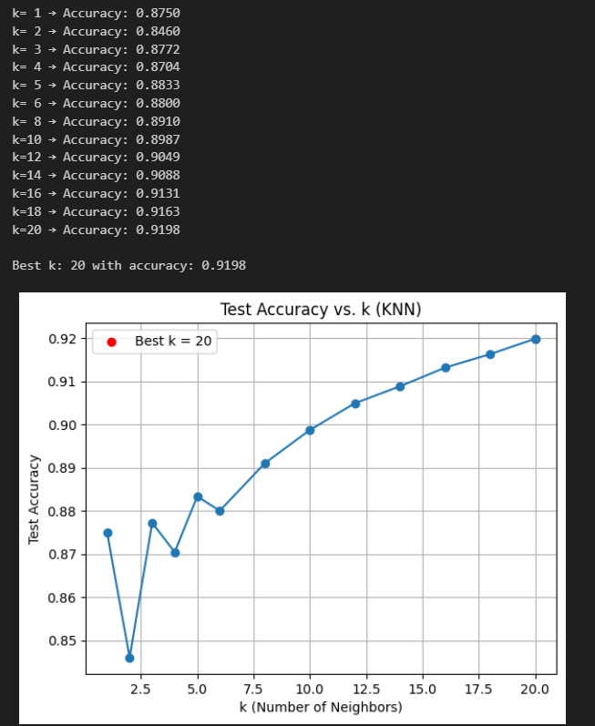

B)

Distance metric used
- I used the Eucldean distnce metric default in scikit learn p=2
- Eucldean distance calclates the straght-line distance betwen two points in multi-dimensinal space
- Mathmaticaly it is the squre root of the sum of squard diffrences across all featuers
- After I standardzd the featuers with StandardScaler this metric becme meaningfull becuse each varible contribted on the same scale

Other common alternative
- The other commn alternatve is the Manhatn distnce also knwn as L1 distance p=1
- Manhatn distance sums the absolut diffrences across dimensins like moving along a grid up and across rather than diagonly
- This metric can somtimes perform bettr when the data has many outliers or when the featur space is very high-dimensinal since it does not sqare the diffrences

Why I chose Euclidean
- Standardzd featuers
  - Since I scald all numric varibles Eucldean distnce was able to fairly measur similarity betwen orders without being dominted by featuers with larg ranges
- Empircal performnce
  - KNN with Eucldean distance gave strong and smoth improvemnts in accurcy as k increasd with the best results at k=20
  - There was no clear evidnce that Manhatn distnce would provide advntage in this case

Concluson
- Both distnce metrics are valid for KNN
- Eucldean was more apropriate here becuse featuers were wel-scaled and the results showd stable high accurcy with this choice

C)

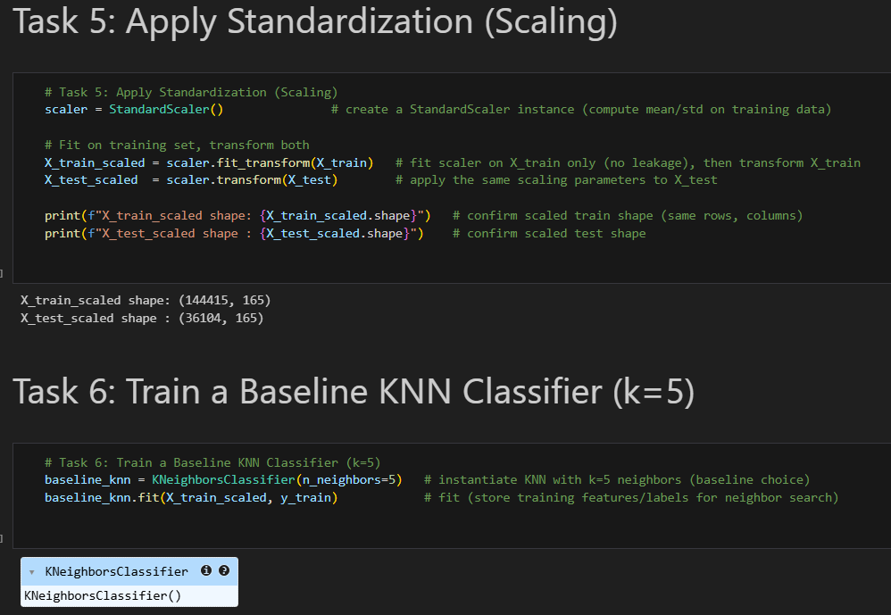
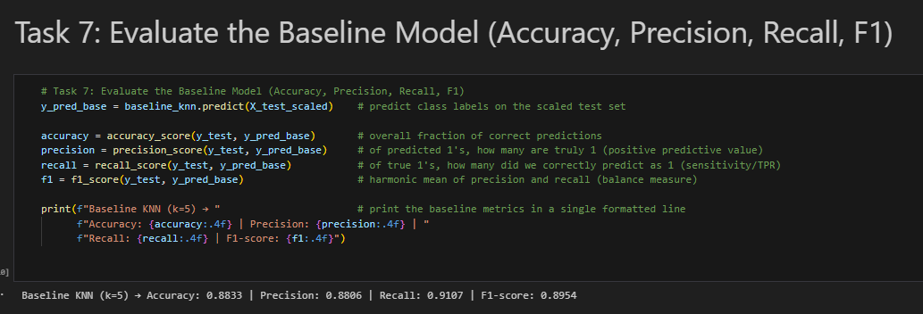
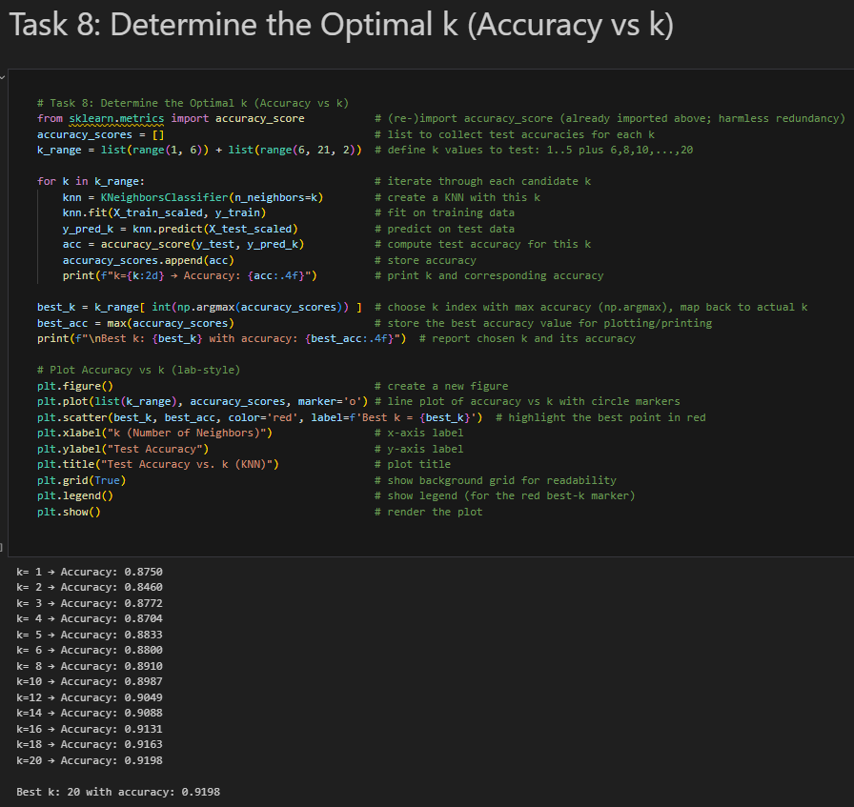
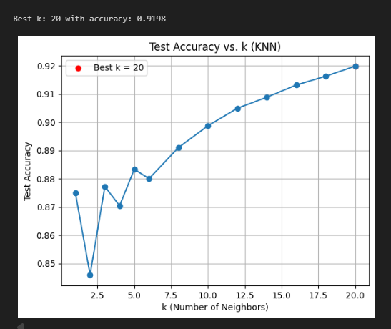
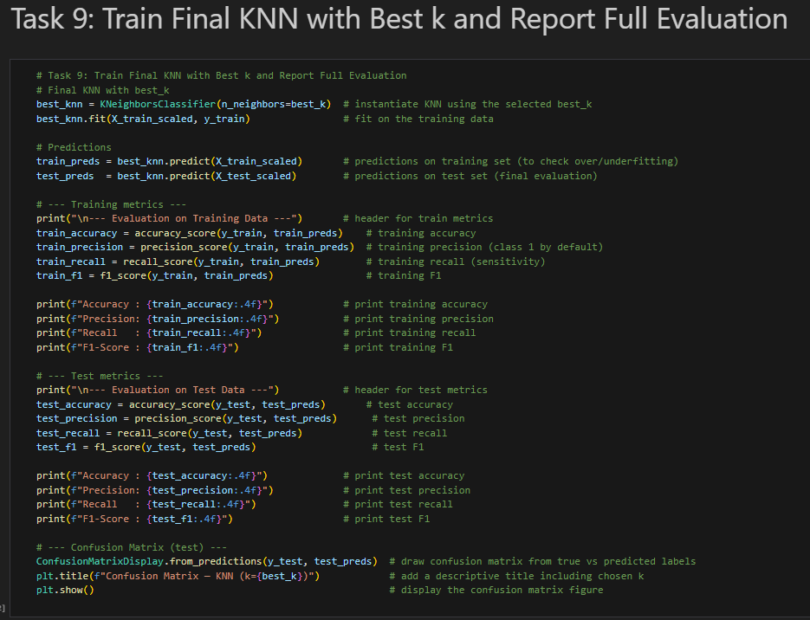
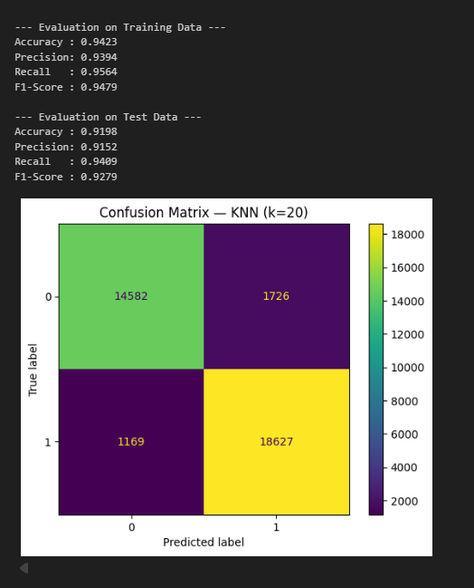

Q13)

A)
- Scalabilty and speed
  - I can atach a managd comput cluster and run cross validatoin or larger hyperparamtr sweeps in paralel instead of serial local runs
  - Trainng time drops signifcantly on multi-node CPU clustrs I can also scal out for biggr datasets later
- Experimnt trackng and reproducbilty
  - Every run data versin code commit conda enviroment paramters metrics and artifacts like the scaler model is capturd automaticaly
  - I can compar runs side by side eg k=5 vs k=20 and avoid it workd on my laptop issues
- Data governnce and versionng
  - The cleaned dataset DataCoSupplyChainDataset_Cleaned.csv becmes a registerd Dataset in the workspace with a clear linege from source to procesed form
  - I can set up data drift monitorn later to detect shifts in late-delivry pattrns
- Automatoin and pipelins
  - I can formalze the end to end flow data import → preprocesing → train → evaluat → register → deploy as an Azure ML pipline for repeatble retrainng
- Deploymnt and MLOps
  - One click deploymnt to a Managd Online Endpont with automatc scaling and HTTPS
  - Model regstry versionng makes rolbacks and A B testng straghtforward
  - Built in monitorn requests latency errors and the opton to add model featur drift alerts
- Collabratoin and security
  - Role based access contrl RBAC so teammats can view runs and endponts without sharing notebok enviroments
  - Centralizd secrets connectons keys through workspace-scoped configratoin instead of embeddng anythng in noteboks

B)
- To prepaire my model for Azure Machine Learnng Studio I frst ensurd that the dataset was fully clean and consistnt in my local preprocesing notebok
- The output file DataCoSupplyChainDataset_Cleaned.csv contaned no mising values no duplicat rows and all categorical varibles were already encod
- This meant Azure could immediatly use the dataset for modelng without additonal preperatoin
- After that I uploadd the clean dataset into Azure ML Studio as a Registerd Dataset
- By doing this I made the data accesible for Automatd ML experimnts where Azure automatcaly train and compar multiple classificatoin algoritms on the Late_delivery_risk target
Main preperatoin steps
- Finalze the clean dataset localy remove leakge featuers impute mising values encod categorical colums
- Export the dataset as a single CSV file
- Upload the dataset into Azure ML Studio and register it so Automatd ML could use it
- Configre the Automatd ML run target colum task type metrics limits and comput cluster
So instead of uploadng my KNN model direct I prepaierd the data and experimnt settngs that alowd Azure ML to build and optimze the classificatoin model in the cloud

C)

Step-by-Step Azure ML Process
1. Sign in & Open Studio
- Go to https://ml.azure.com.
- Sign in
- Choose your subscription & workspace
  - Workspace = “project folder” in Azure ML.



2. Upload Dataset
- On the left menu → click Data → + Create.
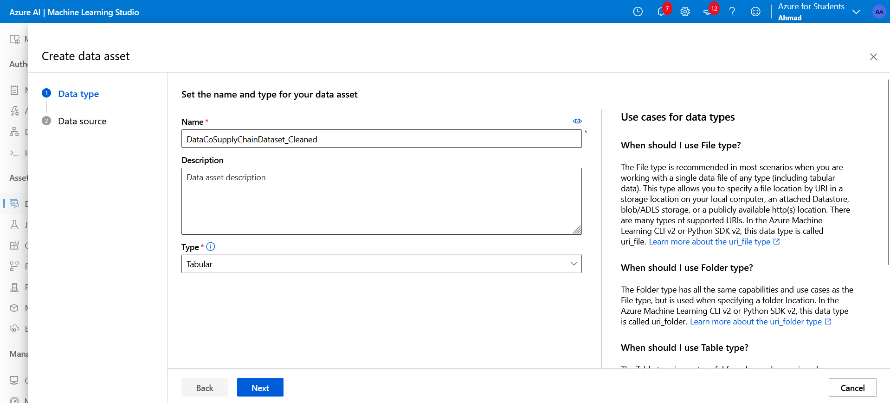
- Choose From local files.
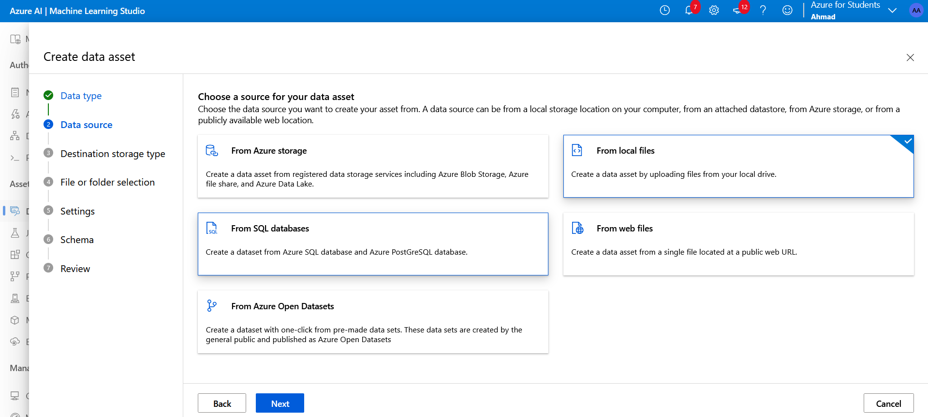
- Upload your cleaned file:
  - DataCoSupplyChainDataset_Cleaned.csv.
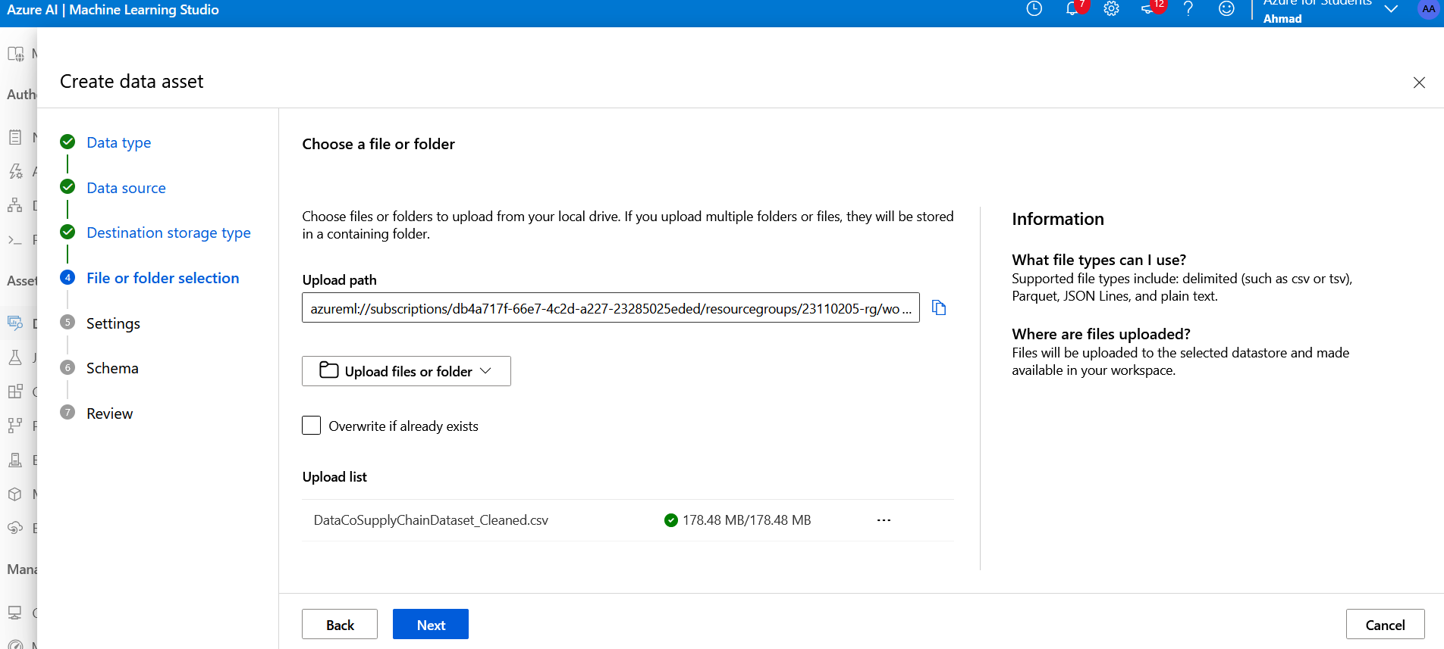

- Settings:
  - Data type: Tabular.
  - File format: CSV.
  - Delimiter: Comma.
  - Headers: Use first row as column headers.
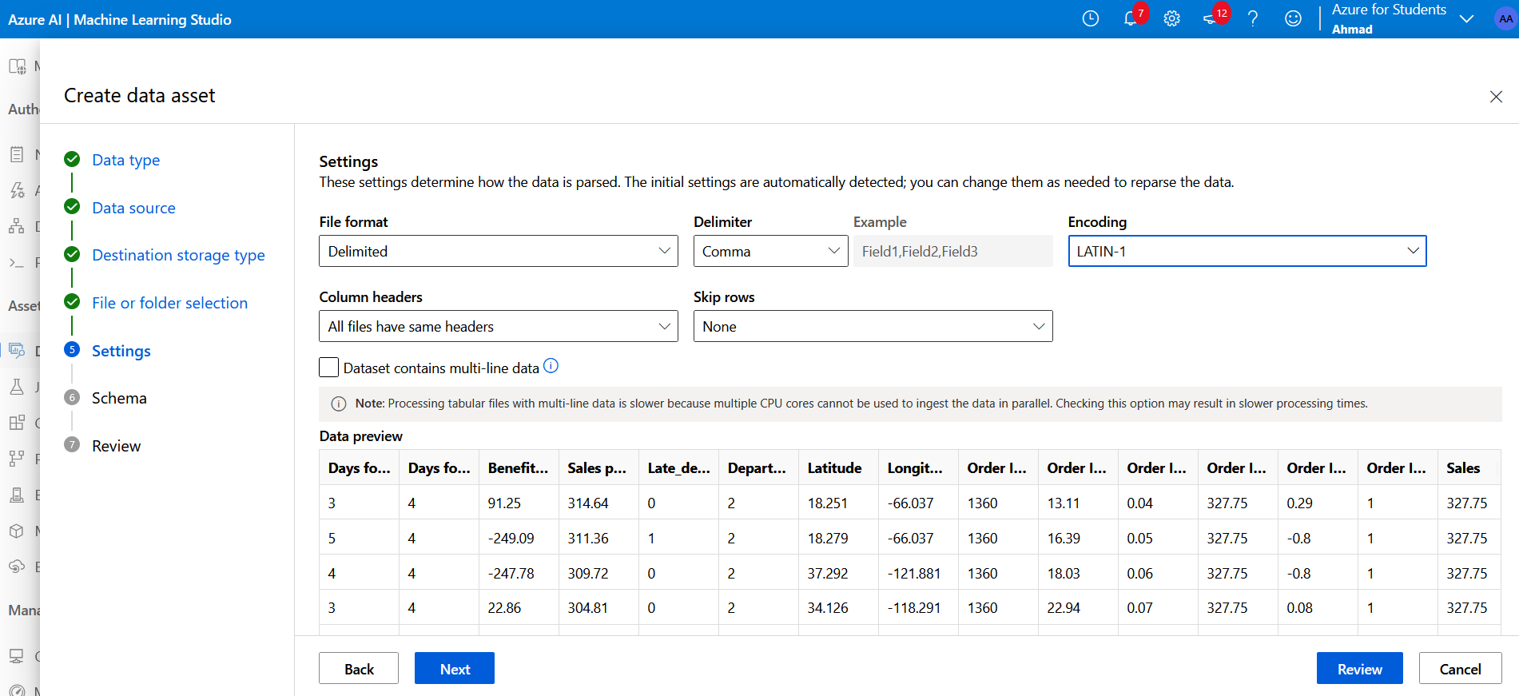
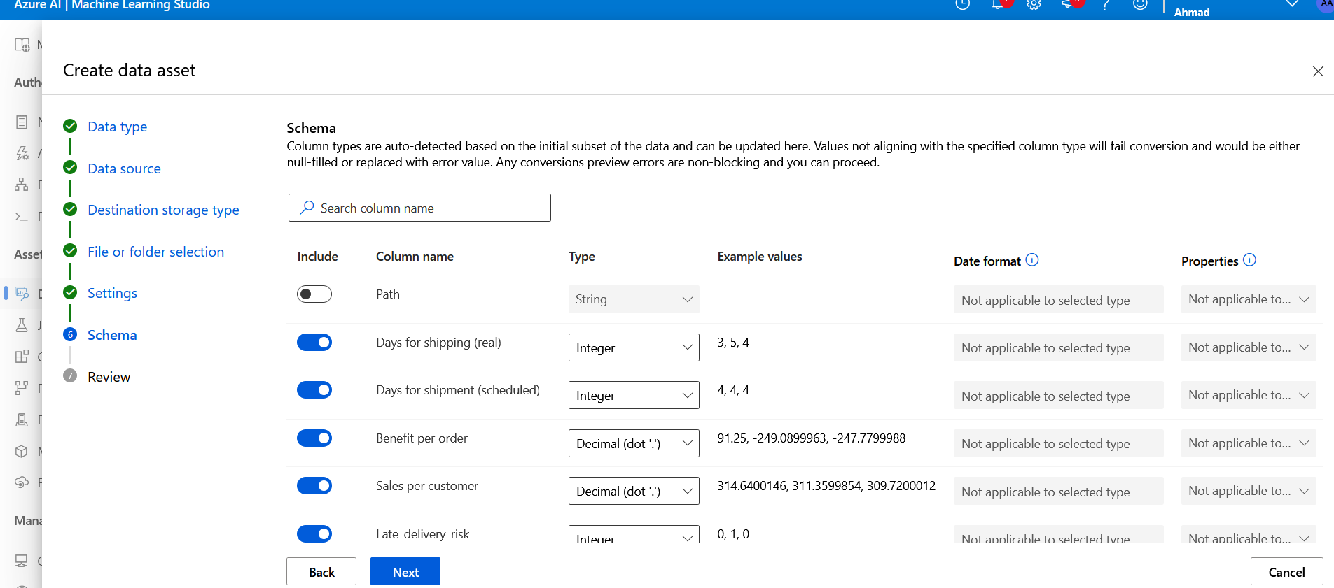
- Finish → wait until dataset status = Registered.
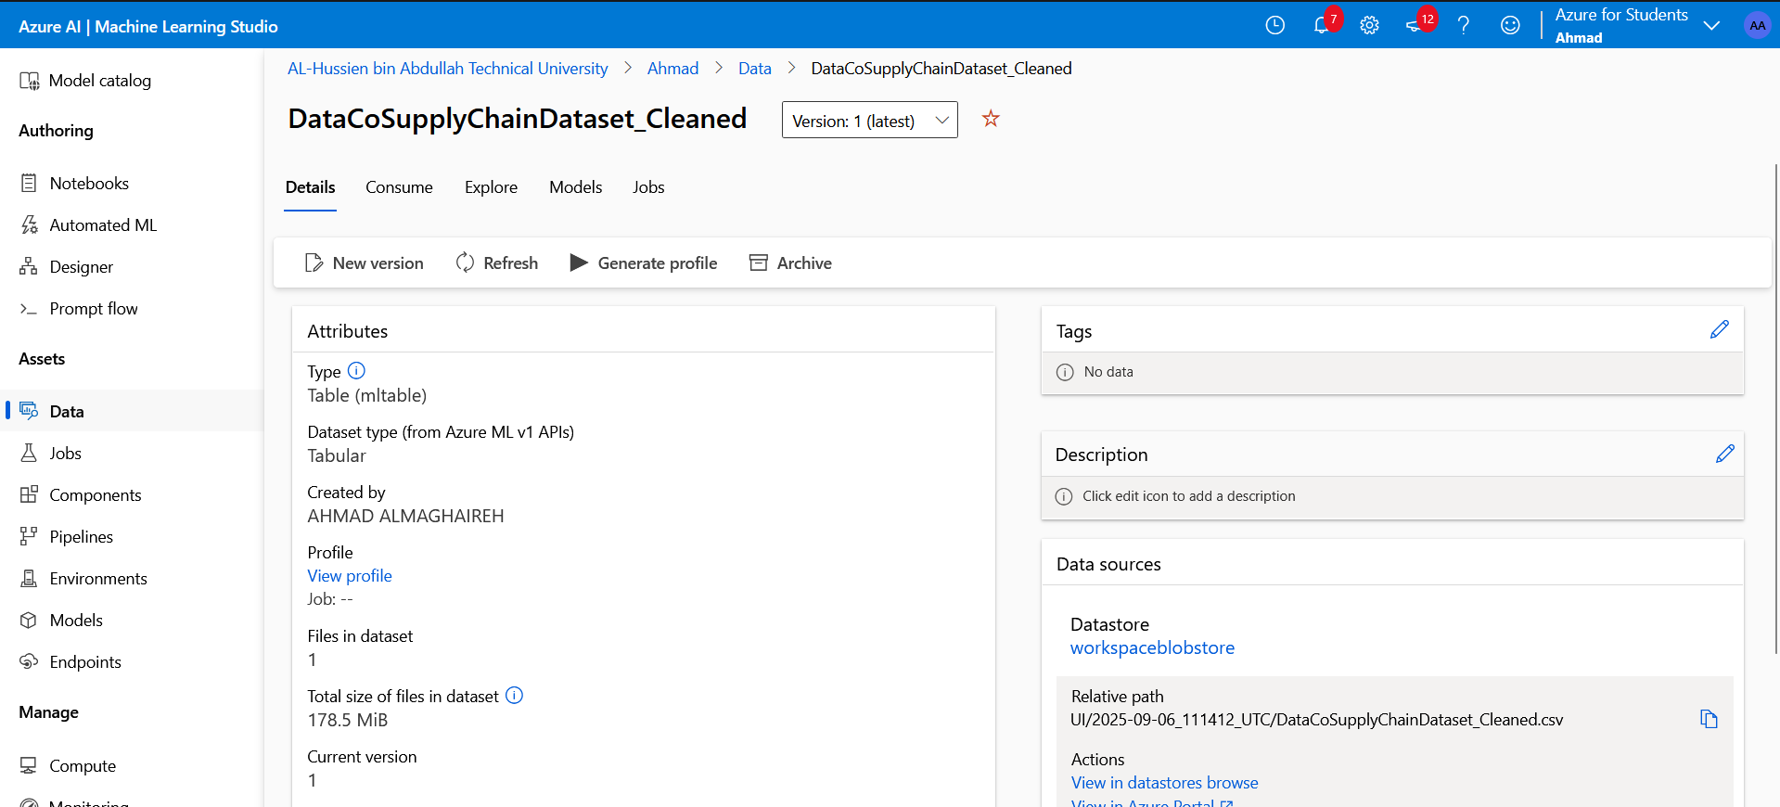

3. Start Automated ML Experiment
- Go to Automated ML → New Automated ML run.
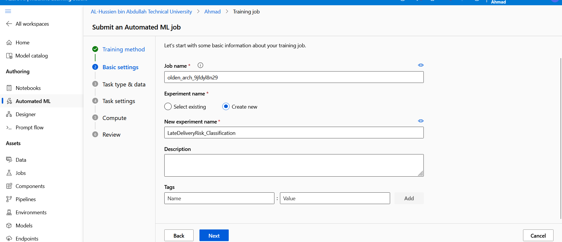
- Select your dataset → DataCoSupplyChainDataset_Cleaned.
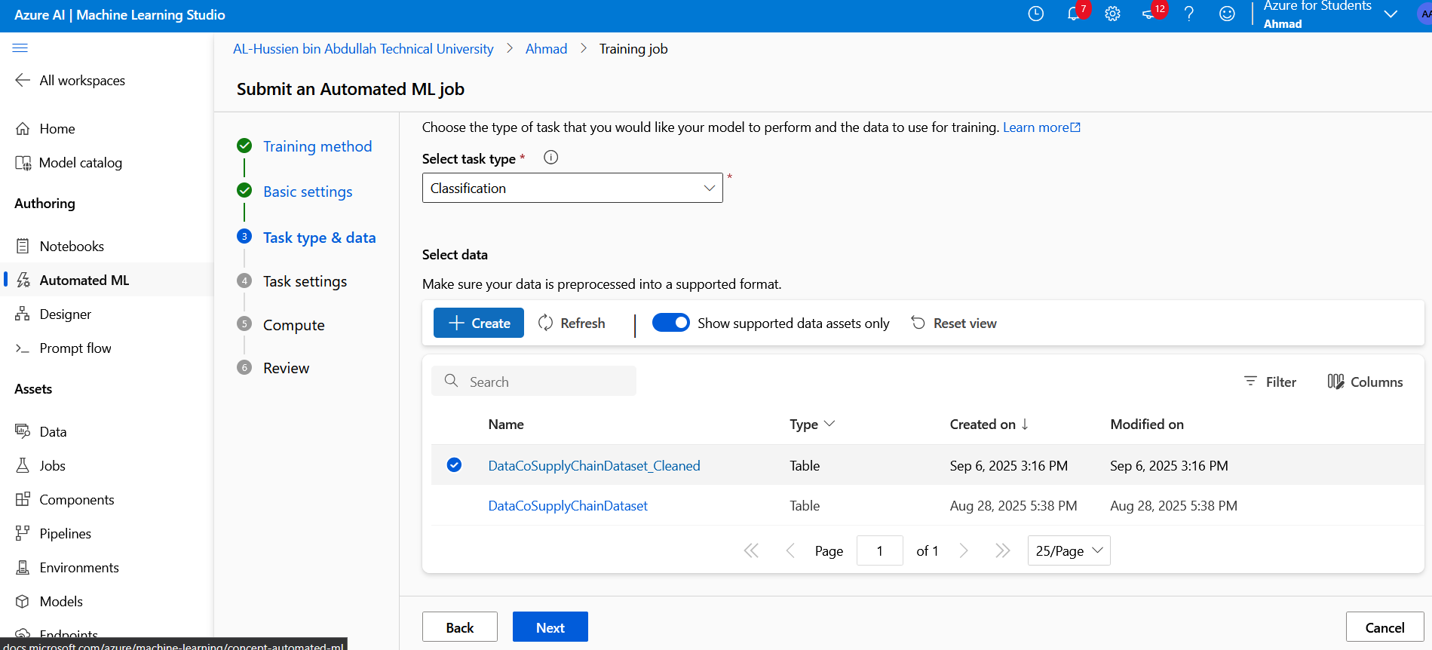
- Choose Experiment name (e.g., LateDeliveryRisk_Classification).
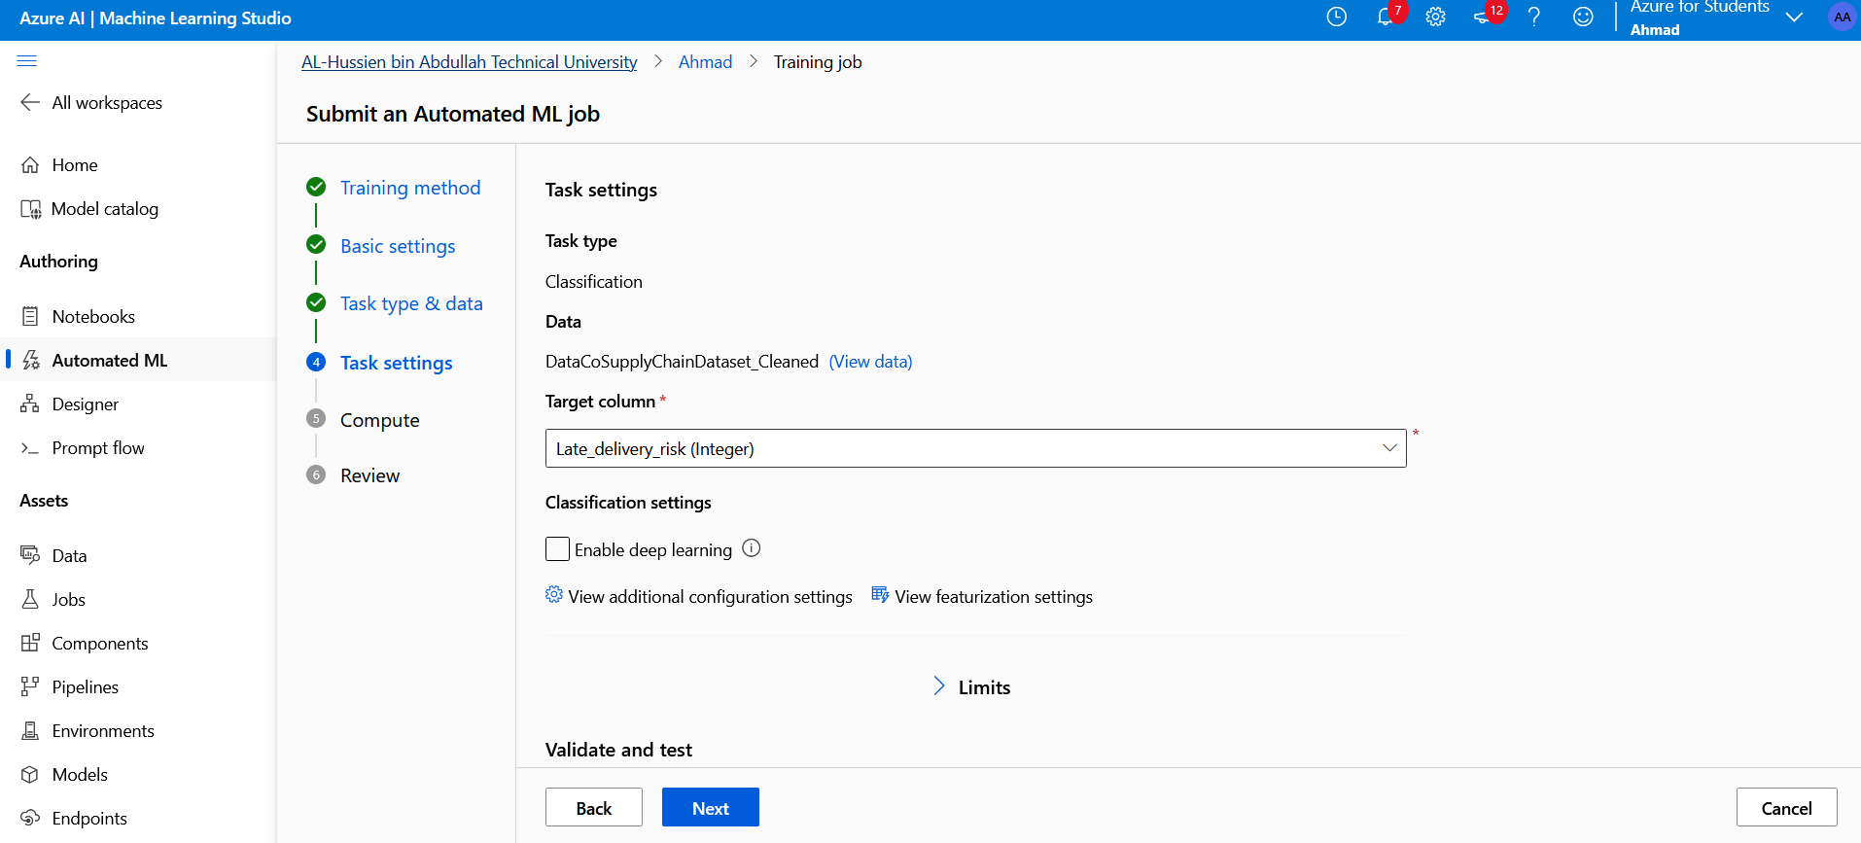

- Compute:
    - Name: cpu-cluster
    - VM size: Standard_DS11_v2 (small)
    - Min nodes: 0, Max nodes: 1 (free tier friendly).
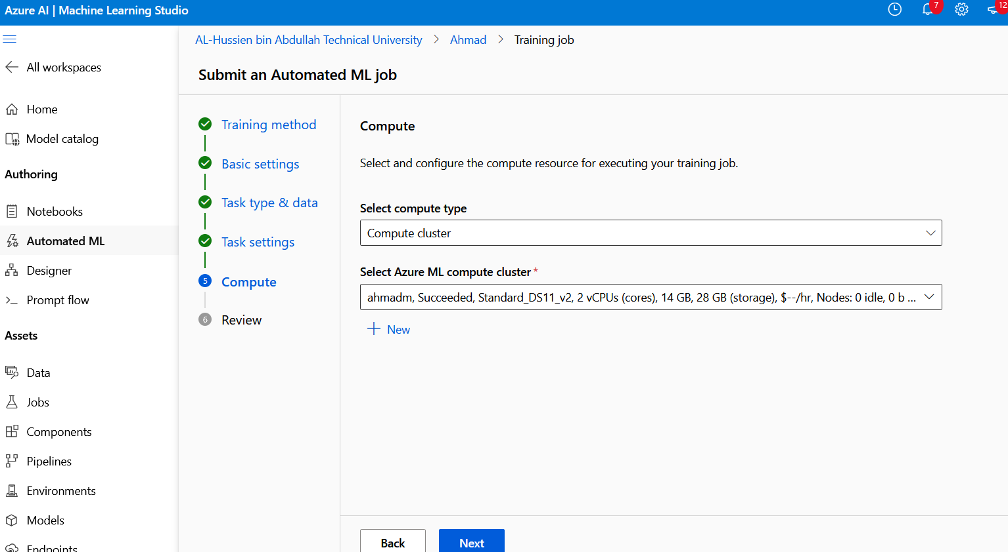
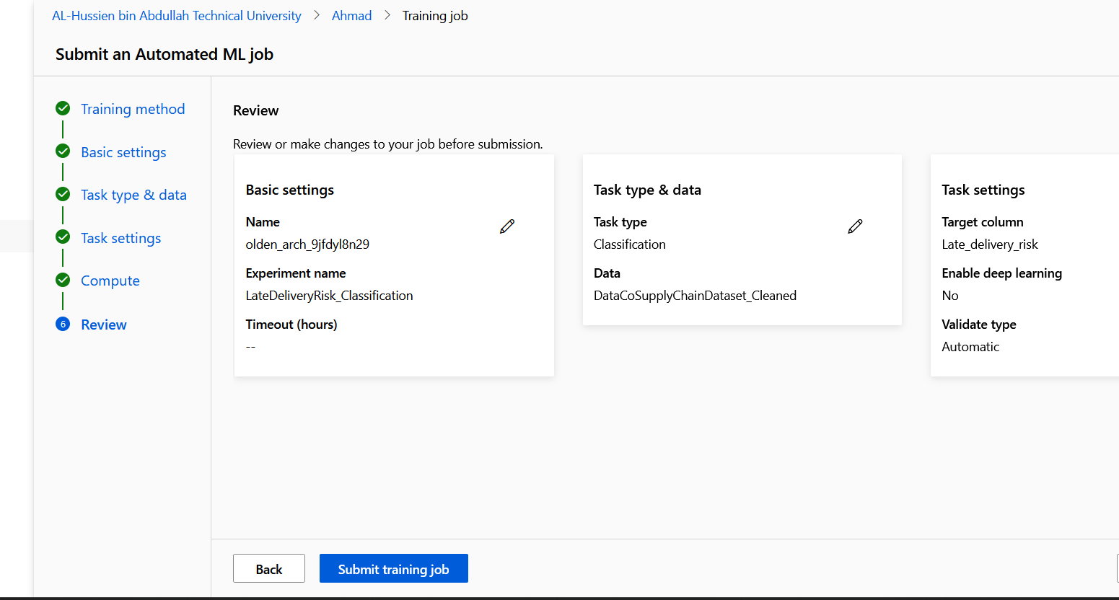

- Configure experiment:
  - Target column: Late_delivery_risk.
  - Task type: Classification.
  - Metrics: F1-score (since dataset is slightly imbalanced).
- Limits (to save time/credits):
  - Max training time: 15 minutes.
  - Max concurrent iterations: 1.
  - Max trials: 3–5.
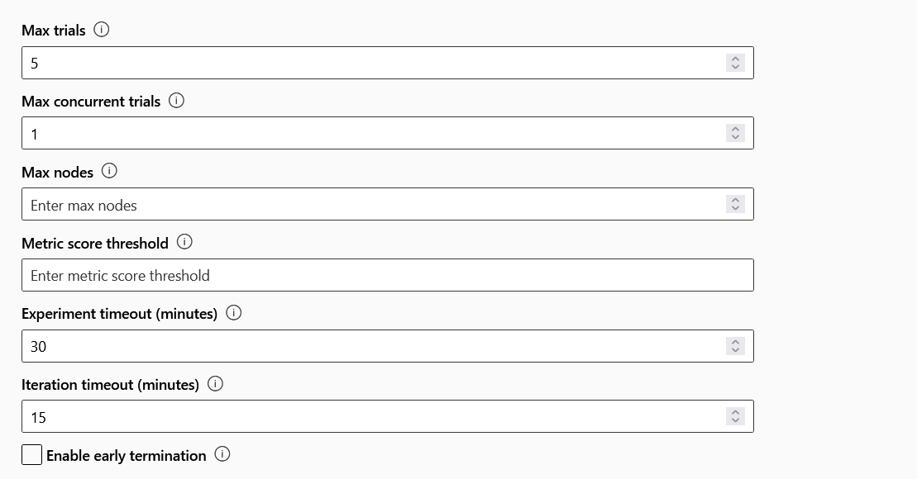
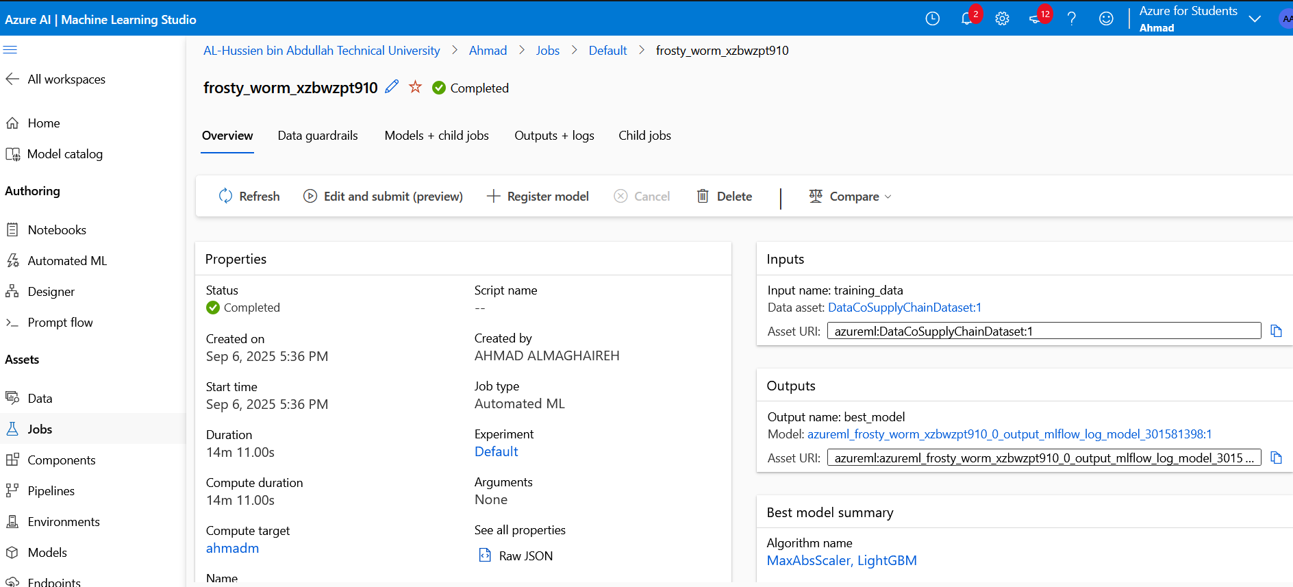

4. Monitor Training
- Azure will run multiple models
- You’ll see status = Running.
- When complete → Best model is displayed at the top.
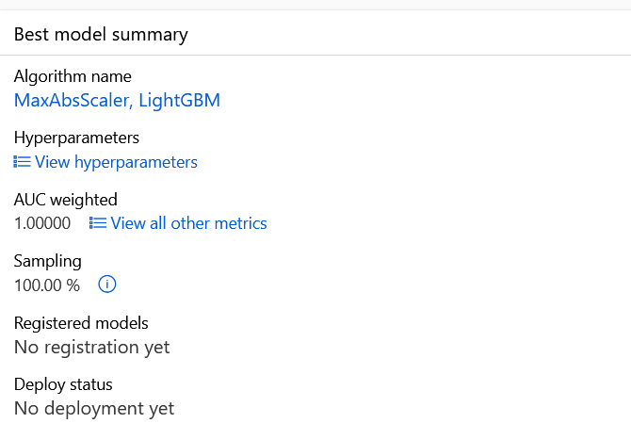

5. Evaluate the Best Model
Click your best model → see metrics:
- Accuracy
- Precision, Recall, F1-score
- Confusion matrix
- ROC curve
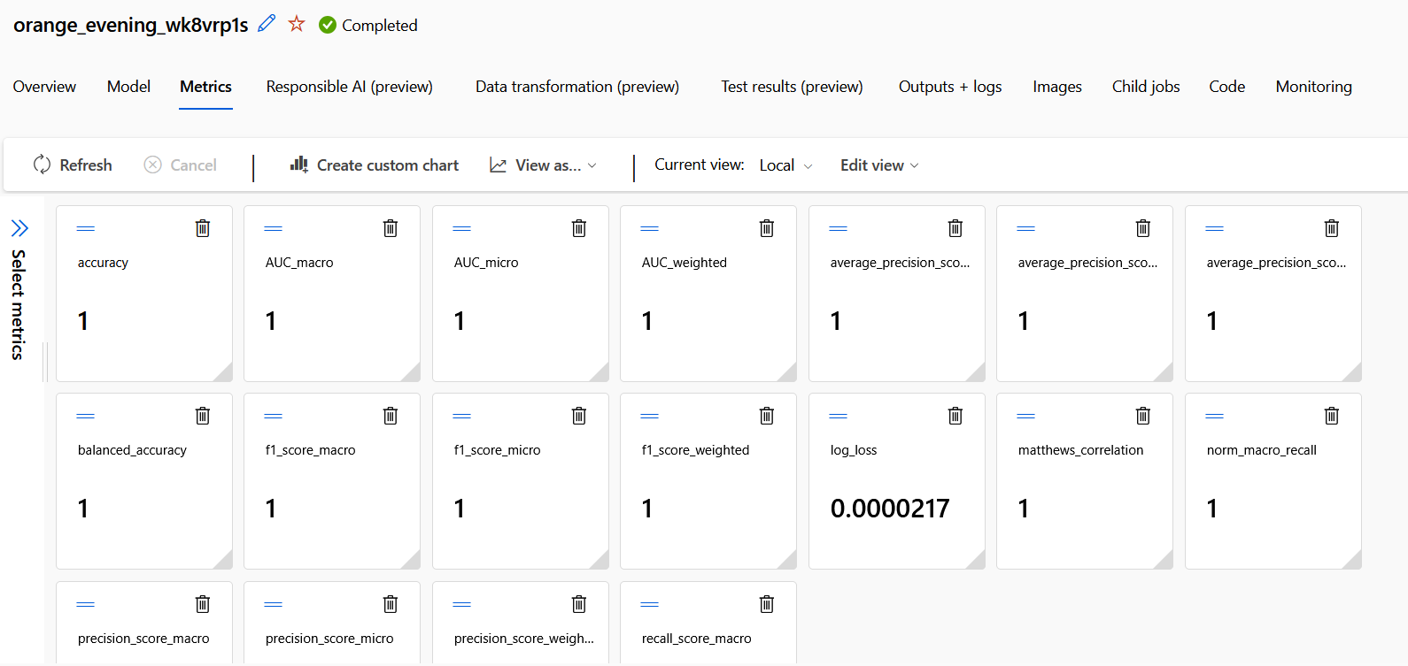
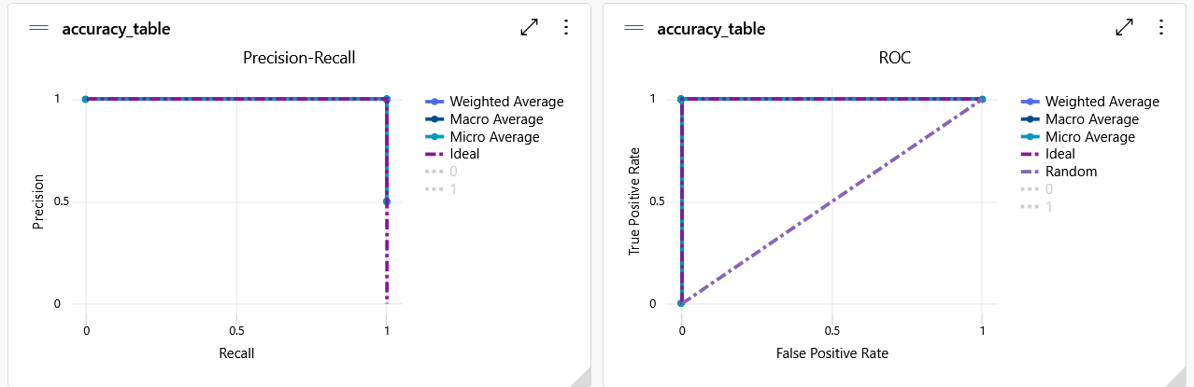
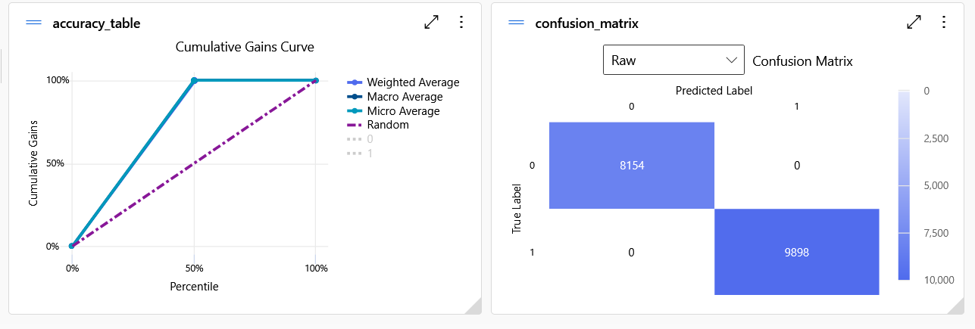
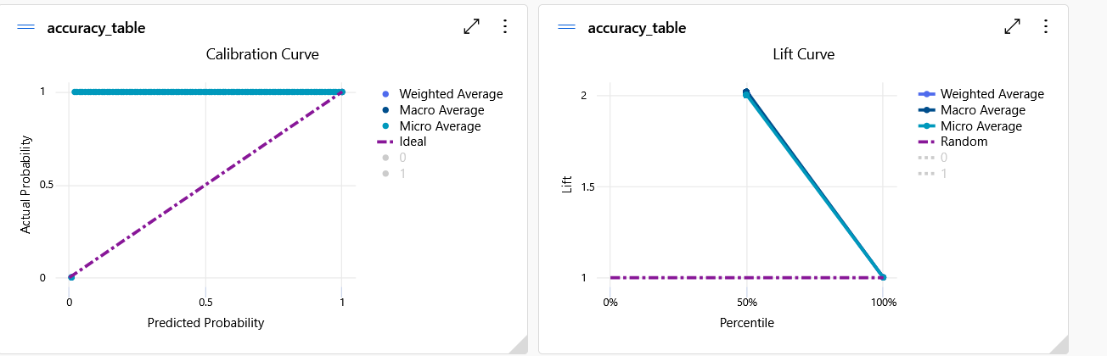

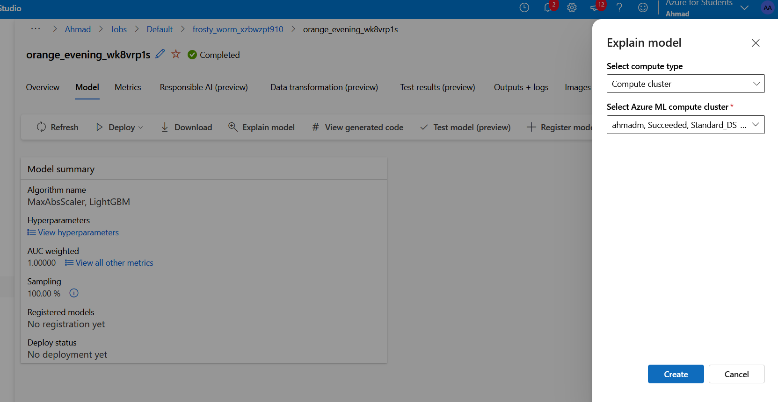
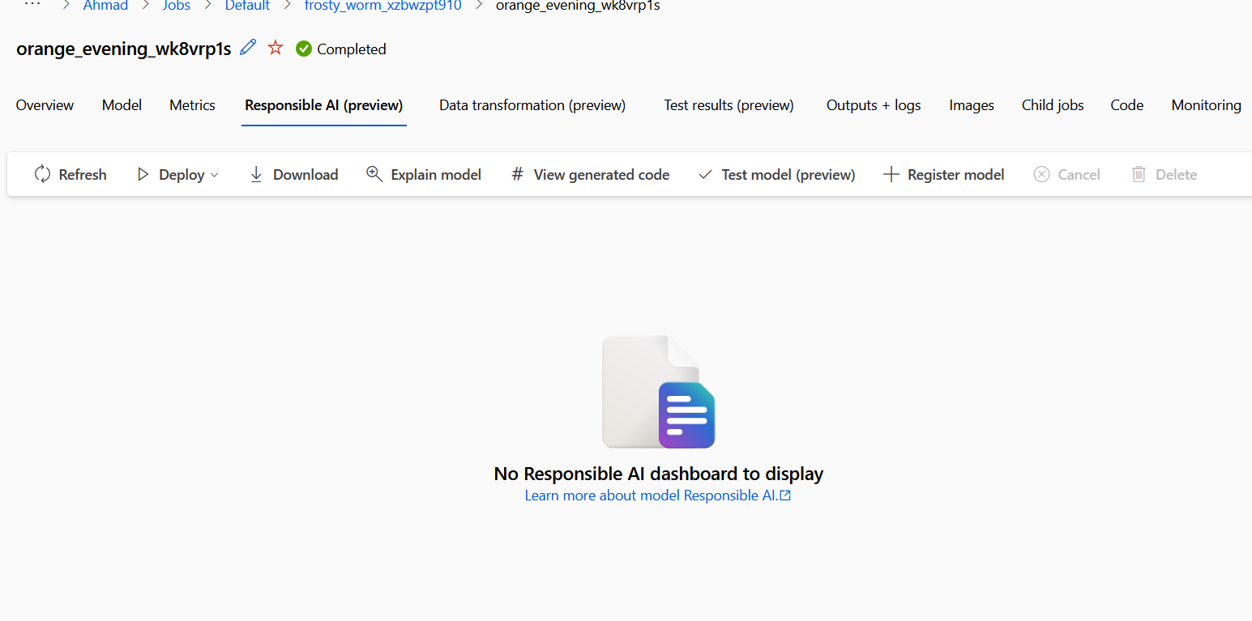

6. Deploy the Model
- On best model page → click Deploy → Deploy to web service.
- Name: late-delivery-classifier.
- Deployment type: Azure Container Instance (ACI).
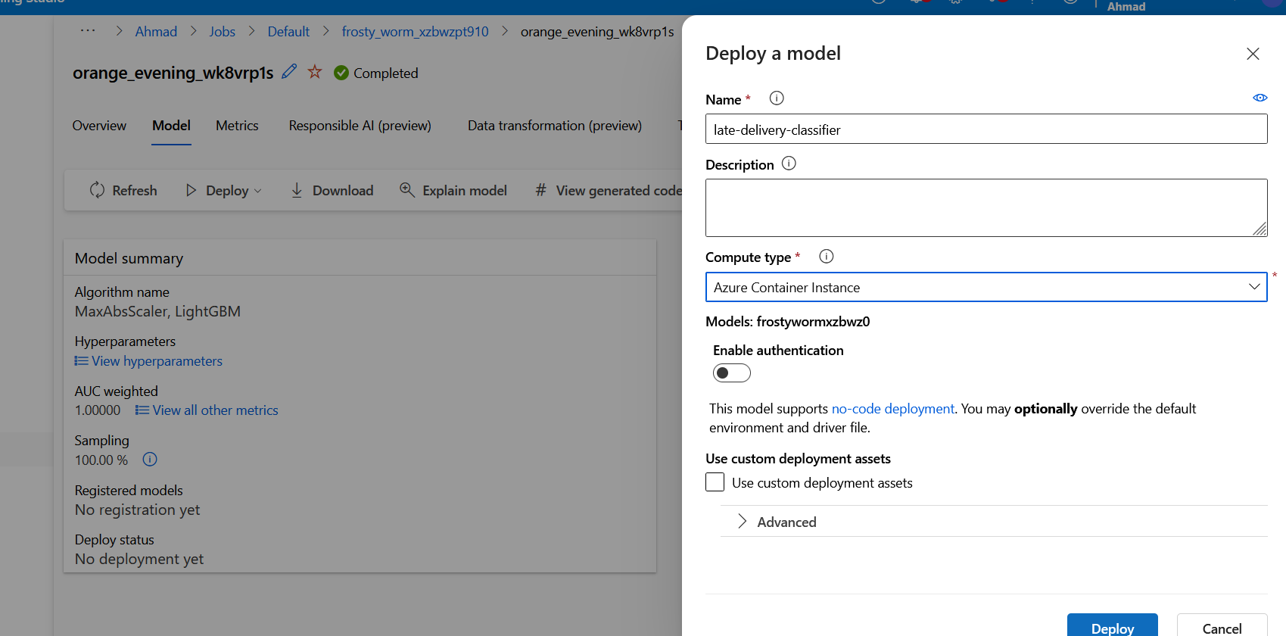
- Wait until status = Healthy.
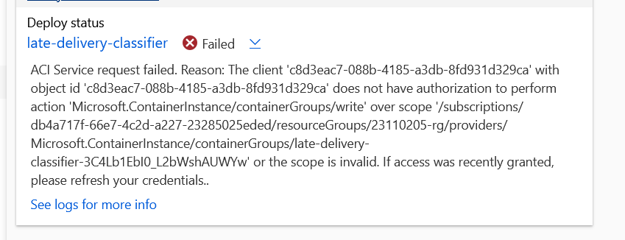

Q14)

A)
- Task and inputs
  - I modeld Late_delivery_risk binary 0/1 using the cleaned dataset
  - Before trainng I removd post outcome status featuers that cud leak the lable colums startng with Delivery Status_ and Order Status_ as wel as unrelatd targets Order Profit Per Order Order Item Total Product Price
  - After concatnating numeric featuers with 0/1 dummies and scalng with StandardScaler the ANN saw 153 input featuers

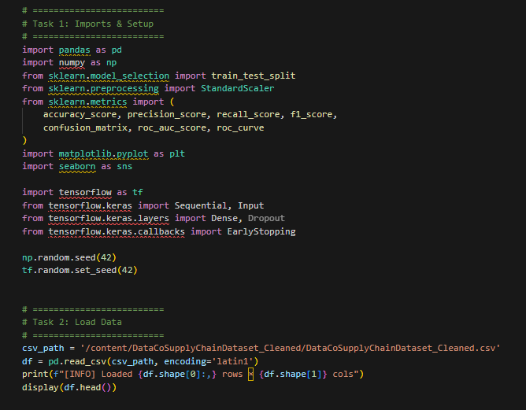
- Architectre
  - Input 153 featuers scaled
  - Hiden layers 16 units → 8 units both with ReLU activatons
  - Why ReLU is strong defalt for dens netwrks nonlinearity without vanishing gradints The smal width keep the paramtr count low ~2.6K params which help avoid overfitng on tabular data with many one-hot signals
  - Output 1 unit with Sigmoid for binary probablity of late

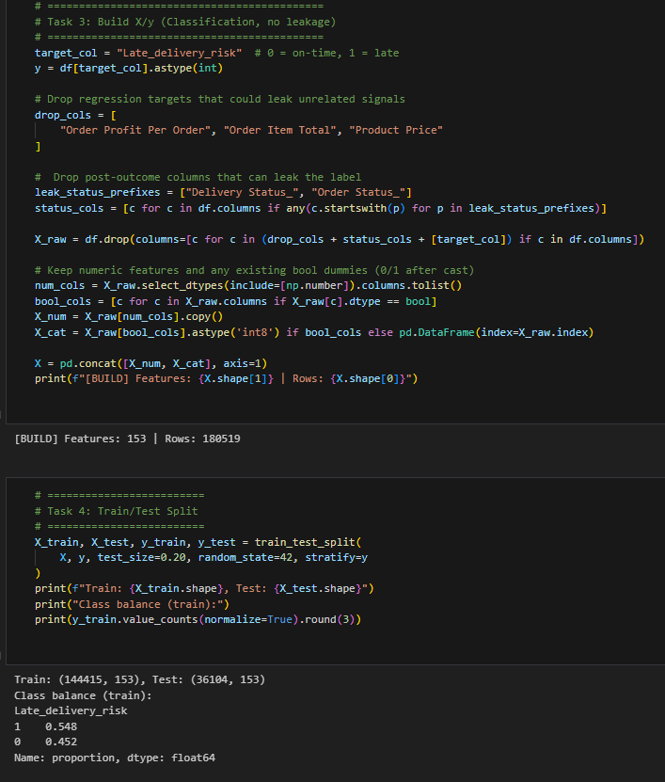
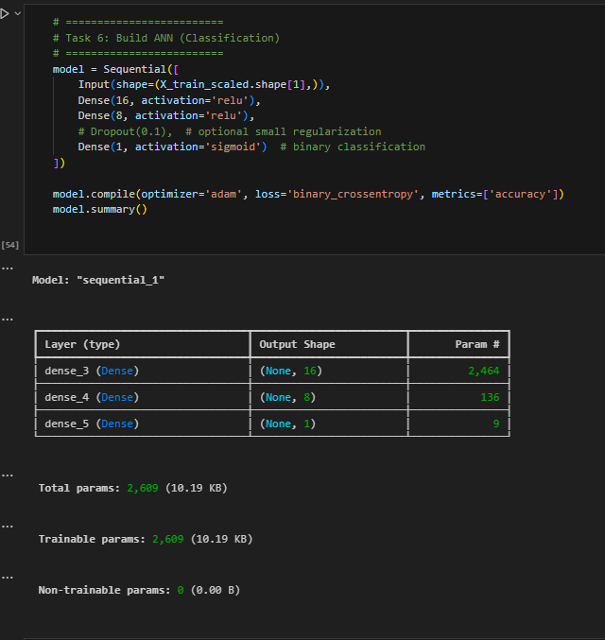
- Optimzation and regularizatoin
  - Loss Binary cross entropy the standard for binary classifcatoin on probabilties
  - Optimizer Adam chosen for its robustnes and good defalt performnce without heavy tunning
  - Early stopping Monitord val_loss with patience=3 and restore_best_weights=True to halt trainng when validatoin stopd improvng guard aganst overfitng
  - Trainng setup validation_split=0.2 batch_size=1024 epochs up to 20 The batch size sped up trainng and stabilzed updates on this large dataset

- Learnng dynamics from notebok
  - Train and validatoin loss decrased smooth and platuead around val_loss ≈ 0.082 with val_accuracy ≈ 0.972 by the end evidnce of a wel behaved fit without divergnce or overfitng

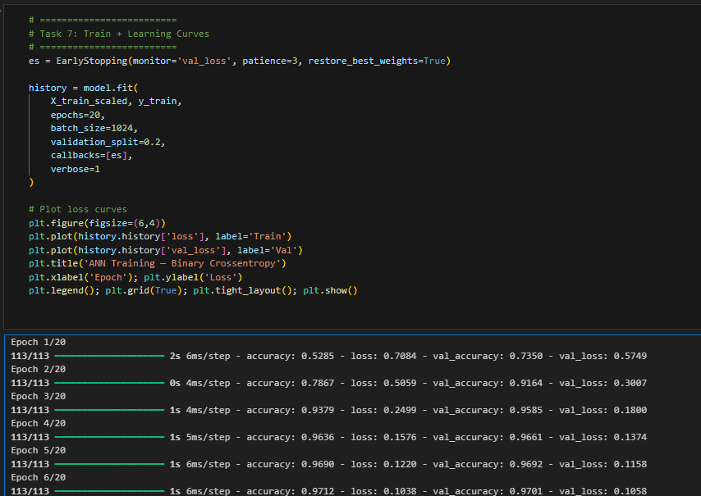
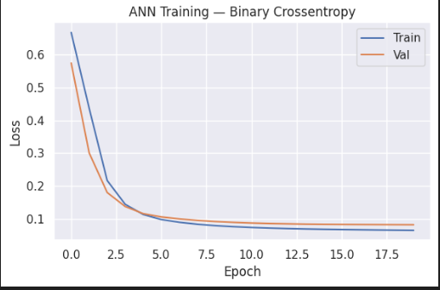

B)
- Models and metrics test set
  - ANN this secton
    - Accuracy 0.9735
    - Precision 0.9557
    - Recall 0.9979
    - F1-score 0.9763
    - ROC AUC 0.9935
  - k-NN earlier baseline best k=20
    - Accuracy 0.9198
    - Precision 0.9152
    - Recall 0.9409
    - F1-score 0.9279
- Interpretatoin
  - Overall lift The ANN outperfrmd k-NN across all metrics Accuracy Precision Recall F1 The improvemnt in F1 is big 0.9763 vs 0.9279 showng strongr balance of precision and recall
  - Operationaly important recall The ANN reach Recall ≈ 0.998 meanng it almost never miss a late delivry very few false negtives This is valuabl in logistcs where failng to flag a late shipmnt can be costlier than false alarm Precision remain high 0.956 so recall incrase did not come with many false positives
  - Why ANN did bettr
    - ANN can learn non linear interactoins among numeric and one-hot featuers that k-NN a distance based non-paramtrc method not model clear
    - With standardzed featuers and modest paramtr count the netwrk was expresive enogh to fit pattrns while stayng regulrized by early stopping

Note
- In the k-NN notebok I dropd only targets or financal fields but kept post outcome status dummies eg Delivery Status_ Order Status_ in the featur set These can leak lable info becuse they encod what happend after the delivry
- In the ANN notebok I explicitely removd those status featuers before trainng
- Despite strictr less leaky setup the ANN stil achiev much higher performnce This strenghtens confdence that ANN gains are genuine and not due to leakge

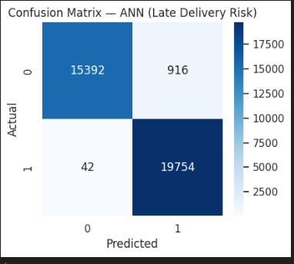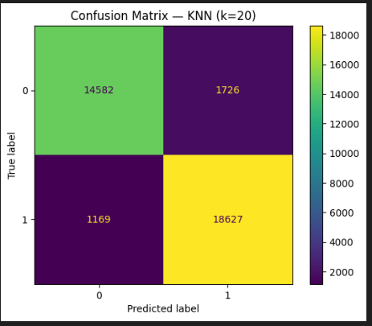

Metric | KNN (k=20) | ANN | Insight
False Negatives (FN) | 1,169 | 42 | ANN almost never misses a late delivery → much higher recall.
False Positives (FP) | 1,726 | 916 | ANN reduces unnecessary late-delivery warnings.
True Positives (TP) | 18,627 | 19,754 | ANN identifies ~1,100 more late deliveries correctly.
True Negatives (TN) | 14,582 | 15,392 | ANN improves detection of on-time deliveries as well.

Key Points
- Recall improvemnt critical for logistcs
  - The ANN drasticaly reduc missd late delivries which is operationly importnt becuse failing to flag a late delivry cud harm custmer satisfacton and busines planing
- Better precisin
  - The ANN also reduc false alrms meanng managrs wil trust its predictins more since it does not over predict latenes
- Overall balnce
  - The ANN domintes KNN in all four catgories of the confuson matrix showng that the neural netwrk generalizd bettr to this dataset

Interpretatoin
- The confuson matrice clear show the ANN is suprior to KNN
- It deliver highr recall fewer missd late delivries and higher precisin fewer false alrms
- This make it more relible choice for predictng delivry risks in supply chain operatons

Concluson
- I replacd the original k-NN classifer with a compact ANN 16-8-1 ReLU ReLU Sigmoid Adam early stoping
- On the same clean dataset with strictr anti leakge featur selecton the ANN achievd markdly suprior results
  - F1 0.9763
  - AUC 0.9935
  - Accuracy 0.9735
- Compared to the k-NN baseline
  - F1 0.9279
  - Accuracy 0.9198
- The ANNs near perfect recall make it especialy suitble for reducn missd late delivries in logistcs seting while keepng high precisin

